* Group Name:
  + Team TBDragons
* Project title:
  + Card-inal Sin
* Project description:
  + Plot
    - In the not so far off future humans crack the code to time travel, a rogue AI hacked the system and uses it to summon warriors throughout history in an attempt to take over the world, only you (the player) can stop it! Using your own time machine you recruit history's greatest warriors. Romans vs Samurai, Vikings vs Knights, Gods vs Man, Steel vs Flesh. Will you fight in the Battle of the ages? The fate of the human race lies in your hands, times ticking!
  + Gameplay:
    - Players will get a set of warriors of varying power levels and factions. The goal of the game is to use those cards to deplete the opponent's deck or win via a Valorous Victory. Players will have access to different passive abilities, such as stuns,heals, etc.
      * 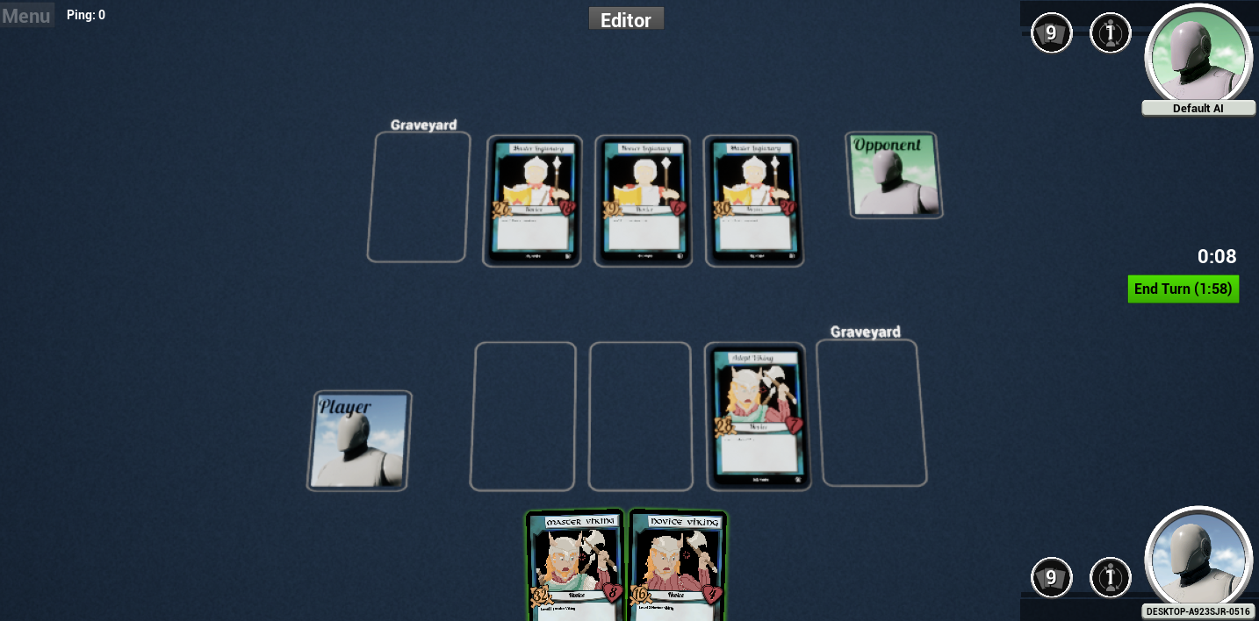
* Mechanics/interface/rules/etc:
  + Core Gameplay
    - You can have up to three cards on the field at a time. After you put a card on the field, it can attack an opponent card and it can be attacked by an opposing card.
    - Only one card can attack per turn
    - Cards can only attack others directly in front or adjacent
    - Cards have two stats, HP (the number on the heart in the right) and Attack (the number on the sword in the left). When a card attacks another, the target’s HP is subtracted by the attacker’s Attack.
    - If the target’s HP goes to 0 (or below 0), they die and get moved to the graveyard
    - If the target survives the attack, you take damage equal to their attack
    - You win by either killing all of the opponent’s cards or by getting a Valorous Victory (see Valor System)
  + Passive abilities
    - Vikings (Berserker)
      * Upon death you deal half damage to the attacker
        + Damage is rounded to nearest integer
    - Knight (Lazarus Pit)
      * Heal per turn (20% of max. Can’t go above max)
        + Healing is rounded to nearest integer
    - Samurai (Koyaku)
      * Stun the attacking card
        + The stunned card cannot attack and retaliation
        + Does not affect viking passive
    - Legionaries (Phalanx)
      * Splash damage of 25% to adjacent enemies
        + Does not get retaliated by enemies damaged by the ability
        + Damage is rounded to nearest integer
  + Valor System
    - Valor
      * Killing an opponent's card gives you Valor equal to the sum of the target’s base health and attack
        + This includes retaliation kills
        + Valor is saved to the card
        + Valor cannot be gained through passive ability kills
    - Reclaimed Valor:
      * Killing an opponent's card that already has Valor will reward the attacking card with Valor equivalent to ⅓ of the target’s current Valor in addition to the amount they would normally gain.
        + Rounded to nearest integer
    - Valorous Victory:
      * If the total Valor held by the cards on your side of the field is equal or greater than 280 you win
  + Deck Building
    - Point bank:
      * When you pick a card the total of its stats are subtracted from the bank
        + Max points 420
    - Unlimited copies of any card
      * Excluding face cards, which has a limit of 1
  + Mana Costs
    - Starting amount: 5
    - Gain the same amount of Mana as turn number
    - Mana cost for attack as shown in card stats
* Goals:
  + Custom art for faction cards
    - Art was implemented for all cards
  + Playtest
    - Weekly playtest were done to insure the game was fun and balanced
  + Add custom abilities and mechanics
    - We were able to add all custom abilities and mechanic we set out to do
  + Deck building
    - We were able to implement a version of this in the final week
  + Decorate the play area and add audio
    - We were working on adding these features but ultimately retired them
  + Develop AI
    - AI was fully developed and works
* Tools:
  + Unreal Engine
    - CCG Toolkit
  + Github
  + Perforce
  + Photoshop
* Assessment
  + Positives and Negatives
    - Successes
      * Plan our MVP and the schedule to get there
      * Create art for all of the cards in the Viking faction
      * Planned out the AI
      * Discussed mechanics, and decided on which are crucial and which are stretch goals
      * Set up a version control system for the engine we’re using
      * Set up the basic layout for the game and basic mechanics
    - Pitfalls
      * Perforce issues
      * Art delays
      * Timeframe estimates
      * Scope adjustments
      * Unreal blueprint system
      * Complicated code base (CCG Toolkit)
      * Problems finding good DAW (Digital Audio Workstation)
      * Balancing potential abilities
      * Terminology
  + Workflow
    - We used trello to stay organized and maintained it allowing us to easily communicate with each other and set deadlines
* Lessons Learned
  + Sara
    - I need a lot more practice to be able to make decent estimates for not just how long things will take in actual converted effort, but how long it'll be before I can get to it, and work on estimating my energy/effort budget and how much I can actually commit to stuff instead of just overpromising and trying to make those goals
  + Devon
    - The biggest lesson I have learned this semester is don’t be too ambitious with the MVP, I have to better manage my time as well as be more realistic with scheduling. Oftentimes we had to readjust the timeline. It would have been more efficient if I better accounted for the delays of life ahead of time and left more wiggle room for such occurrences
  + Matt
    - Readjusting scope to add new features like mana, abilities, and valor meant that the AI had to be rescoped, which was something I did not really foresee needing to be done. They added quite a bit of time into the improving AI process
  + Long
    - The biggest lesson I learnt from the project is the importance of time management. I have a lot of homeworks and projects for this semester, and so it’s hard to find time to work on the projects. I also learnt that I should have taken more time to look into the source code more, especially when we are using a complicated source code like the CCG Toolkit.
* Repo:
  + <https://github.com/Long-T-Hoang/CardinalSin>
* Video:
  + https://drive.google.com/file/d/1-L51624LYs8uVI5pM7nBuKAVM1YOBKvc/view?usp=share_link